**Assignment 1**

class Vehicle{

    void start() {

        System.out.println("Vehicle started");

    }

}

class Car extends Vehicle {

    @Override

    void start() {

        System.out.println("Car started");

    }

}

class MotorCycle extends Vehicle {

    @Override

    void start() {

        System.out.println("Motorcycle started");

    }

}

class Garage {

    void serviceVehicle(Vehicle vehicle) {

        vehicle.start();

        System.out.println("Vehicle serviced");

    }

}

public class VehicleMain {

    public static void main(String[] args) {

        Car car = new Car();

        MotorCycle motorcycle = new MotorCycle();

        Garage garage = new Garage();

        garage.serviceVehicle(car);

        garage.serviceVehicle(motorcycle);

    }

}

**OUTPUT:**

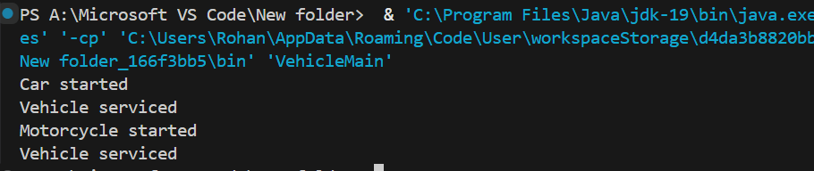

**Assignment 2**

class Student2 {

    String name;

    int age;

    String department;

    public Student2() {

        this.name = "Unknown";

        this.age = 20;

        this.department = "Unassigned";

    }

    public Student2(String name, int age) {

        this.name = name;

        this.age = age;

        this.department = "IT";

    }

    public Student2(String name, int age, String department) {

        this.name = name;

        this.age = age;

        this.department = department;

    }

    public void display() {

        System.out.println("Name: " + name);

        System.out.println("Age: " + age);

        System.out.println("Department: " + department);

    }

}

class Main {

    public static void main(String[] args) {

        Student2 student1 = new Student2();

        Student2 student2 = new Student2("Alice", 22);

        Student2 student3 = new Student2("Bob", 21, "Computer Science");

        student1.display();

        System.out.println();

        student2.display();

        System.out.println();

        student3.display();

    }

}

**OUTPUT:**

